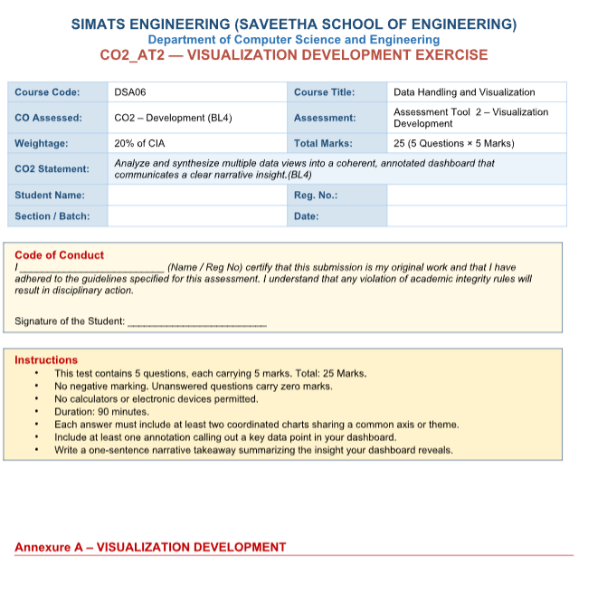

NAME:M.RASHIKA
REG NO:192573010
COURSE CODE:DSA-0606
COURSE NAME:DATA HANDLING AND VISUVALIZATION
CO2
ASSESSMENT -2
Problem 1 — Retail Quarterly Dashboard (5 Marks)
Data: Quarterly revenue and profit margin: Q1 = $200k / 15%, Q2 = $250k / 18%, Q3 = $220k / 12%, Q4 =
$300k / 20%.
Task: Build a two-chart dashboard: a bar chart of revenue and a line chart of profit margin, aligned on
the same quarter axis. Add one annotation highlighting the quarter with the highest margin, and write a
one-sentence takeaway summarizing the overall trend.
OUTPUT:
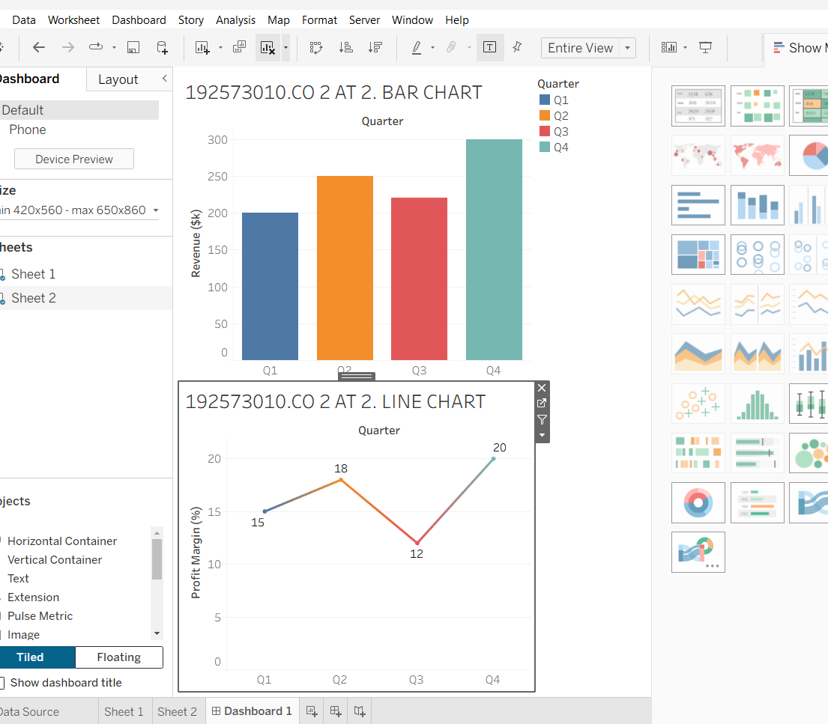

Problem 2 — Marketing Campaign Dashboard (5 Marks)
Data: Channel spend and conversions: Email = $2k / 150 conv, Social = $5k / 300, Search = $8k / 550,
Display = $3k / 90.
Task: Build a dashboard combining a bar chart of spend by channel and a scatter plot of spend vs.
conversions. Annotate the most cost-efficient channel, and add a narrative caption recommending
which channel to increase investment in.
OUTPUT:
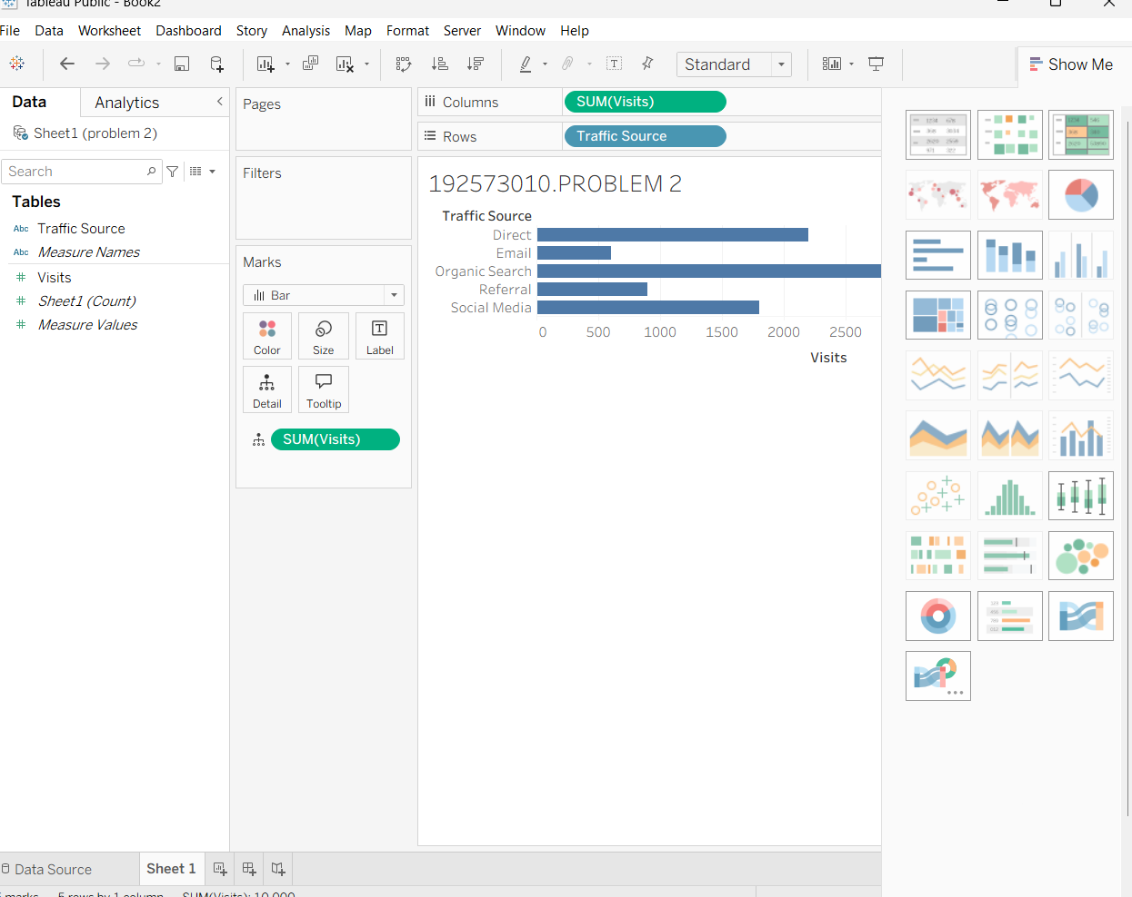
Problem 23 — Fitness App Cohort Dashboard (5 Marks)
Data: Retention rate at week 1 / 4 / 8 / 12 for three signup cohorts: Jan cohort = 100%,70%,50%,35%;
Feb cohort = 100%,65%,40%,20%; Mar cohort = 100%,75%,60%,50%.
Task: Build a dashboard with a multi-line chart showing retention curves for all three cohorts across the
four checkpoints. Annotate the cohort with the steepest drop-off, and write a narrative recommending
the best point to intervene.
OUTPUT: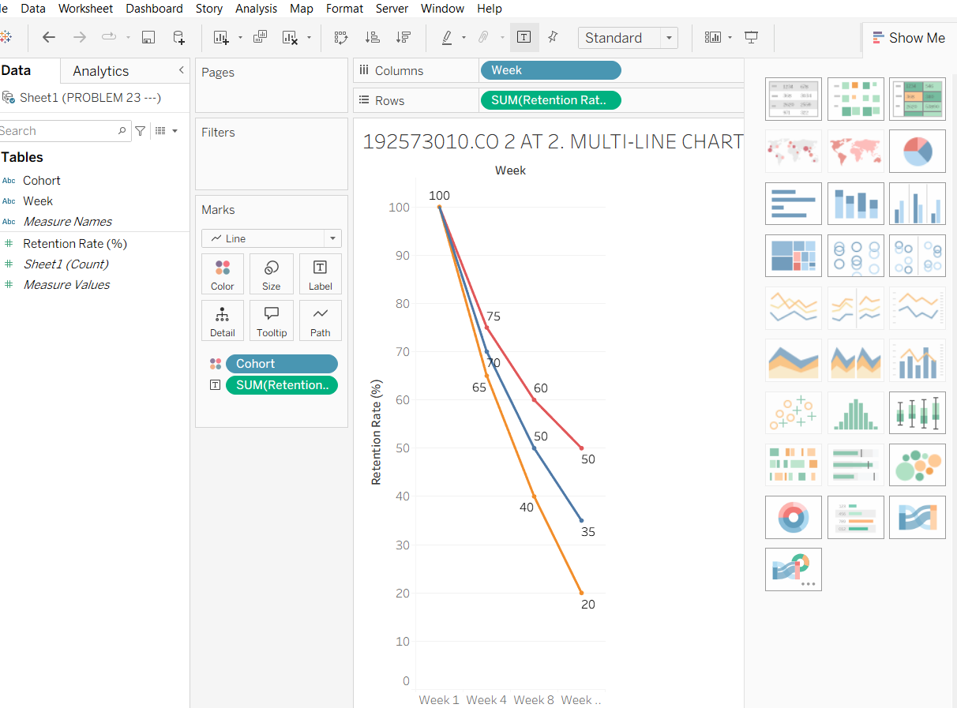

Problem 24 — Weather Storm Tracking Dashboard (5 Marks)
Data: Hourly wind speed (km/h) and barometric pressure (hPa) over 12 hours: wind =
40,45,55,70,90,110,105,85,60,45,35,30; pressure =
1005,1002,998,992,985,978,980,988,995,1000,1003,1006.
Task: Build a dashboard with a line chart of wind speed and a line chart of pressure on the same hourly
axis, stacking the two charts vertically to avoid a dual y-axis. Annotate the peak-intensity hour, and write
a narrative describing the storm's progression.
OUTPUT:
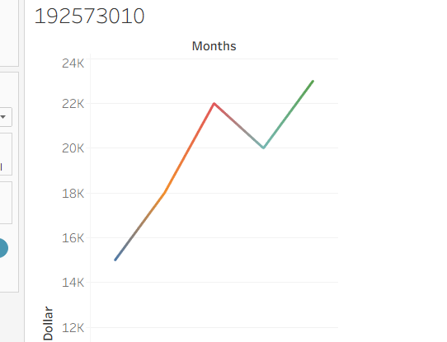

Problem 25 — Company-Wide KPI Dashboard (5 Marks)
Data: Revenue ($M), customer count (thousands), and employee count over 4 years: Revenue =
10,15,22,30; Customers = 50,80,120,180; Employees = 40,55,70,95.
Task: Build a small-multiples dashboard with three aligned mini-charts (one per metric) sharing the same
year axis. Annotate any year where growth patterns diverge across the three metrics, and write
OUTPUT:
